Harrow Youth Centre
Summer Fun Day Camp

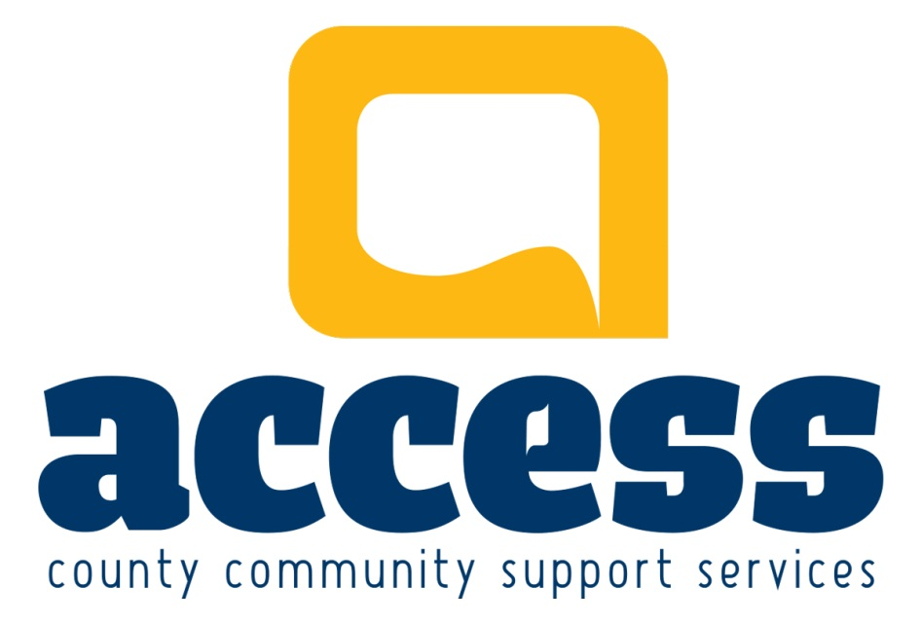

Parent Guidelines

HARROW SUMMER FUN DAY CAMP
PARENT GUIDELINES

Methods of Operation:

Hours of Operation:
Monday to Friday – 8:30am – 5:30pm

Ages for Program:
Children & Youth – Grades 1-8
**Your child must be entering Grade 1 in September 2018**

Late Pick-Up
There will be a fee charged for any pick-ups that occur after 5:30pm. A fee of $5.00 will be applied in 15 minute increments.
Examples: A fee of $5.00 for any pick-up that occurs between 5:30 and 5:45. $10.00 for any pick-up that occurs from 5:45-6:00, etc.

Absenteeism
If your child will not be attending on their scheduled day, the Youth Centre needs to be informed by 9:30am.

Notification of Injuries/Incidents to Parents:

Whenever a child sustains any emotional or physical injury they will be comforted and given first aid as appropriate.
The incident/injury will be reported to the parent/guardian by the Program Coordinator or Assistant Program Coordinator on the same day. An injury report will be completed and signed by the parent, employee providing the First Aid, as well as the Harrow Site Coordinator.
If the parent does not pick the participant up from programming, a copy of the Injury Report will go home with the child explaining how the accident happened and how the child and staff responded to it.

Children’s Health:

- If a child is ill, the attending staff will notify the parent/guardian. The staff would also make a decision and follow through with the appropriate action (isolation, discharge, or re-entry), ensuring that the parent receives accurate re-entry information for any contagious disease.
- While waiting for the parent, ill children may be separated from the other children in order to stop the spread of infection
- Under certain circumstances the Supervisor may request a doctor’s note for re-admittance to the program.

Safe Sun Practices:
During our Summer Camp we will be spending time outside. It is important that you provide your children with proper protective clothing and sunscreen.

Guidelines for Using Sunscreen:
- No sunscreen products containing insect repellent will be administered in the youth centre.
- Parents will be responsible for writing the child’s name on the label of a product and signing the label as to not get personal property mixed up with other camp participant’s.
- Children will be encouraged to apply their own sunscreen under adult supervision.
- Participants who are of the same family are welcome to share sun screen, however sharing skin products among friends and other camp participants will not be allowed.

Safe Practices for Use of Insect Repellent Lotion:

Guidelines for Using Insect Repellent:
- Parents or guardians may provide insect repellent lotion containing 10% or less DEET. No aersol sprays, spray pumps or insect repellent containing sunscreen will be administered in the youth centre.
- Only insect repellents registered under the Canada’s Pest Control Products Act will be applied to children. The application of insect repellent lotions will adhere to the manufacturer’s directions.
- Children will be encouraged to apply their own insect repellent lotion under adult supervision.

General Nutrition Guidelines: Meals and Snacks:

Parents or guardians are responsible for providing their child(ren) with a lunch and snacks for the day. We will have two snack and one lunch break throughout the course of the day.

When packing your child(ren)’s lunch and snacks please keep in mind that we have participants with food allergies. Please refrain from sending peanut products.

Drug Administration:
If your child requires medication, you will be asked to complete a “Consent for Drug Administration Form”. Medication will be kept locked on site and must be in the original container, with the Child’s name, Drug name and administration instructions.
There are two exceptions where medication will not be locked – A child may carry his or her own asthma medication or emergency allergy medication (including Epi-Pens).
An EpiPen or other emergency allergy medication will be stored on site at the centre in an unlocked cupboard identified with the EpiPen Emergency Treatment Plan indicating; the child’s name, and expiry date of medication.

Transporting Children:
Children will be walking together as a group with staff members from the Harrow Youth Centre Location on 18 Queen St. Harrow, to St. Anthony’s Catholic School, the park/ splash pad, nature trails, or other walkable locations in town. You will be given notice of these events taking place. Please make sure that your child is prepared with proper attire for various weather conditions (e.g. umbrellas, hats, running shoes, etc.).

Literacy and Numeracy:
The Harrow Youth Centre is able to deliver Summer Day Camp via funding from the Catholic School Board. Without this funding, we would not have the financial means to provide a summer camp. With this being said, there are specific guidelines that we as the facilitators of the camp are expected to follow; this will include a variety of literacy and numeracy activates woven into our day to day camp schedule. These activities may be in the form of math/ puzzle games, story or journal writing, “Drop Everything and Read” (D.E.A.R.) time, etc. participants of the Harrow Youth Centre summer camp are expected to participate in these activates to the best of their ability.

Final Note:
Feel free to contact the supervisor if you have any questions or concerns about these guidelines, the program, or the registration process. We wish to work together to ensure that your child’s experience is a positive one.

Contact Information:

Phone: 519-738-4050
Email: hberlasty@accesscounty.ca

